function onChange(control, oldValue, newValue, isLoading, isTemplate) {
if (isLoading || newValue === '') {
return;
}

if (newValue!=''){
var optionRemove =['1','6','7','8'];

g_form.setValue('state','2');

optionRemove.forEach(function(item){
g_form.removeOption('state',item);
});

}

}
function onChange(control, oldValue, newValue, isLoading, isTemplate) {
if (isLoading ) {
return;
}

if (newValue!=''){
var optionRemove =['1','6','7','8'];

g_form.setValue('state','2');

optionRemove.forEach(function(item){
g_form.removeOption('state',item);
});

}else {
g_form.clearOptions('state');
g_form.addOption('state','1','New',0);
g_form.addOption('state','2','In Progress',1);
g_form.addOption('state','3','On Hold',2);
}

}
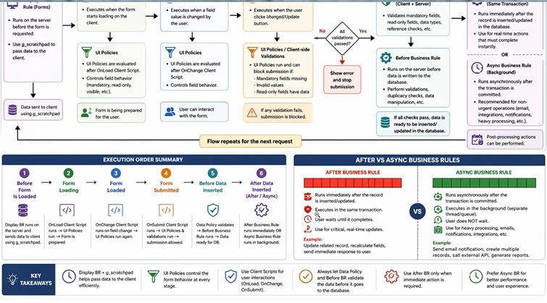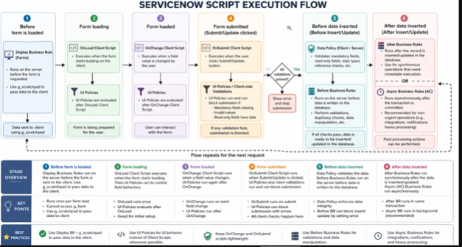

(function executeRule(current, previous /*null when async*/) {
var gr = new GlideRecord('u_telephone_directory');
gr.addQuery('u_mo_number',current.u_mo_number);
gr.query();
if(gr.next()){
current.setAbortAction(true);
gs.addWarningMessage('Same Mobile Data Available');

}

})(current, previous);
(function executeRule(current, previous /*null when async*/ ) {

var gr = new GlideRecord('sys_user');
gr.initialize();
gr.setValue('name', current.u_caller);
gr.title = 'Telephone Customer';
var id = gr.insert();
current.u_reference_1 = id.toString();
current.update();

})(current, previous);
(function executeRule(current, previous /*null when async*/) {

var gr = new GlideRecord('u_telephone_directory');
gr.addQuery('u_mo_number',current.u_mo_number);
gr.query();
if(gr.next()){

current.setAbortAction(true);
gs.addErrorMessage('Same Phone Number Available for Custome ID '+gr.u_number);

}else{

var user = new GlideRecord ('sys_user');
user.initialize();
user.setValue('name',current.u_caller);
user.mobile_phone=current.u_mo_number;
user.title='Telephone Customer';
var id = user.insert();

gs.addWarningMessage('User Got Created in ServiceNow ');

current.u_reference_1=id.toString();

}

})(current, previous);
- Create from doctors and patients make them when creating them to be created in user table
var unique={};
var duplicatecount=0;
var createduser=0;
var reuseusercount=0;
var proceeseddoccount=0;

var gr = new GlideRecord('u_doctor');
gr.orderBy('sys_created_on');
gr.query();
while(gr.next()){

var docName= gr.u_doctor_name;
if(unique[docName]){
gs.print('Deleting Duplicate Record'+gr.u_doctor_name+' | ');

gr.deleteRecord();

duplicatecount++;
continue;
}

unique[docName]= true;
proceeseddoccount++;

var userID='';
var usr= new GlideRecord('sys_user');
usr.addQuery('name',gr.u_doctor_name);
usr.query();

if(usr.next()){
userID=usr.getUniqueValue();
reuseusercount++;

}else{
var user= new GlideRecord('sys_user');
user.initialize();
user.name= gr.u_doctor_name;
user.mobile_phone=gr.u_phone;
user.email=gr.u_email;
userID = user.insert();

createduser++

}

gr.u_doc_user=userID.toString();
gr.update();

}
(function executeRule(current, previous /*null when async*/ ) {

var gr = new GlideRecord('sys_user');
gr.initialize();
gr.setValue('name', current.u_caller);
gr.title = 'Telephone Customer';
var id = gr.insert();
current.u_reference_1 = id.toString();
current.update();

})(current, previous);
(function executeRule(current, previous /*null when async*/) {
var number=[];
var shortdes=[];
var gr = new GlideRecord('incident');
gr.addEncodedQuery('active=true^stateNOT IN6,7,8^caller_id='+current.caller_id);
gr.query();
while(gr.next()){
number.push(gr.number.toString());
shortdes.push(gr.short_description.toString());

}
g_scratchpad.xyz=number.join(', ');
g_scratchpad.abc=shortdes.join(',:: ');
g_scratchpad.count=gr.getRowCount();

})(current, previous);

